1st Grade Connection
October 27-31, 2025

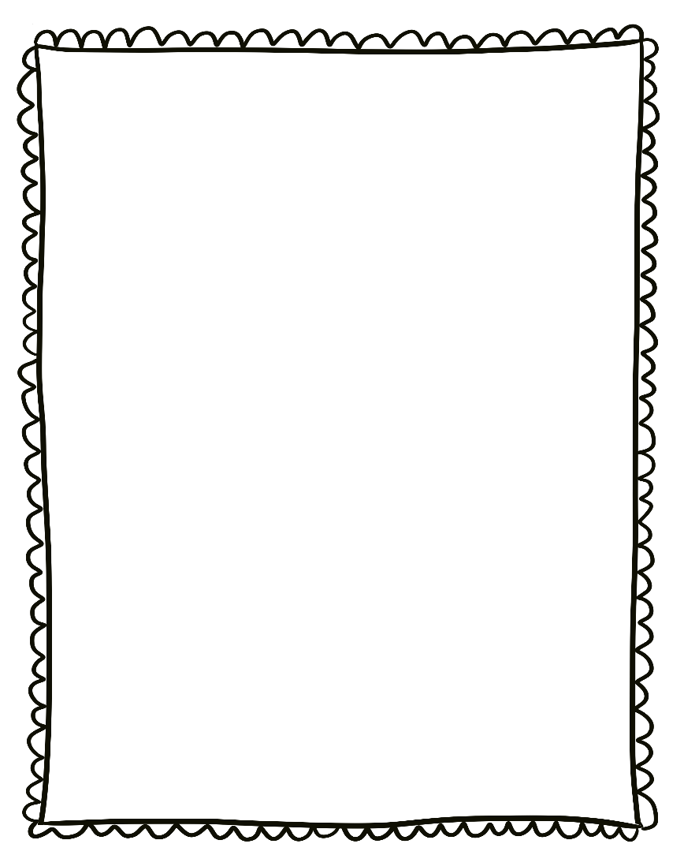
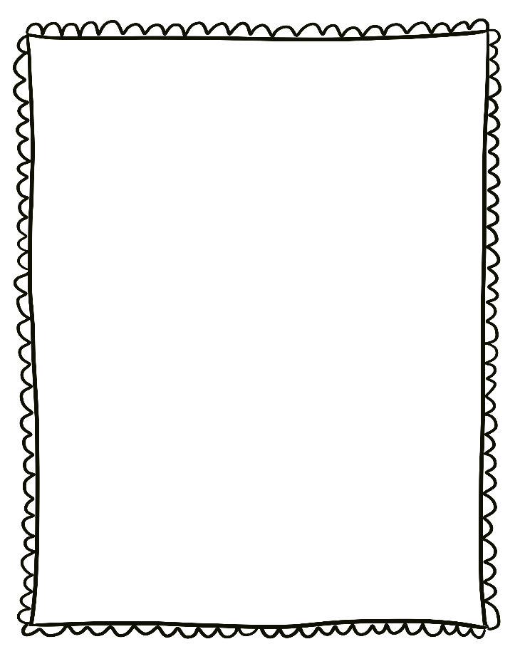
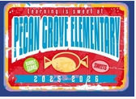
- Monday, October 27-31: Red Ribbon Week
- Wednesday, October 29th: Wear it Wednesday-College or Military wear
- Thursday, October 30th: Field Trip to the Oil Ranch
- Friday, October 31st: Book Character Parade! 8:30am

- Please send a nutritious snack that is easy to eat to school with your student. All snacks must be peanut free. Examples of this include Cheez-Its, Pretzels, or baby.
carrots.

- Wear tennis shoes on PE days!

- Reading: Thinking deeply about stories-comprehension strategies

- Phonics: Long vowels (open syllables)

- Writing: Personal Narratives

- Conventions: Punctuation marks at the ends of sentences-declarative, exclamatory, interrogative

- Math: Problem solving

- Social Studies: Map Skills

- Science: Force and Motion

Reminders:

Upcoming Events/Grades
What we are learning:

